

**GetRichToday**

**The Foremost Financial Firm**

***“From Bankrupting BiteCoin to Building Business, We’ve done it all”***

Pham, Michael

Twitter: @TheRealDanaldTrump

**Table of Contents**

**Title……………………………………………………………….1**

**Table of Contents……………………………………………...2**

**Mission Statement……………………………………………..3**

**ExpensesReport……………………………….………………4**

**MarketResearch………………………………………………..5**

**Employees………………………………………………………6**

Our Mission  
Description

A Russian Financial Advisory Dedicated to the welfare of the people.

Our company is manned by 69 employees - each one hand-picked by the CEO himself.

The Story of GetRichToday began with the rise of Bitecoin Solar Industries. Experts told us investing was too risky. But we invested $10b and monopolized the market. After spending millions to engineer hype, GetRichToday, as a major investor, sold its shares at the market high. In a maddened frenzy, consumer confidence reached an all-time low. Why did the largest investor abandon the market? This must be the work of an enemy stand. Perhaps it knew something they didn’t, that the glorious sun that once guided Bitecoin Solar Industries had begun to set. Then GetRichToday revealed a crucial detail: Bitecoin Solar Industries was led by an incompetent CEO. The stock price plummeted, and investors abandoned all hope, wanting nothing more than to flee the ruin. But who was happier to take those discounted shares than the company of the people, GetRichToday? It answered the cries of the people, lifted their burden, and proceeded to generate a massive profit as it replaced the CEO.

GET RICH TODAY FINANCIAL ADVISORY BUSINESS PLAN

We are willing to do anything for our clients, whether it be exploiting the market, trading inside information, and subtle collusion. As long as we make a profit, we’ll do it all.

For the ethical investor, we offer several mutual funds that have historically matched and exceeded the market. The results will match that of any competent investor, and have low commissions compared to hedge fund managers. You can also sign up for our $1000 course that’ll teach you how you too can beat the market. We also offer our $300 book *The Art of the Deal*, which reflects the strategies of the most powerful man in America, alternatively known as our largest client.

For now, we will focus on defeating the capitalistic hedge fund managers. Upon success, we will concentrate our resources into manipulating the United States Congress and supporting our invested industries.

We offer a pyramid scheme course designed to steal your money and demonstrate the power of scams and how to avoid them. Only $1000, guaranteed to teach those foolish enough how to avoid similar scams.

We’re in this for the long run.

Expenses

As GetRichToday, we have a duty to serve the citizens and exploit their assets. Little is it known that founder Charlie Ponzi (no relation to Charles Ponzi whatsoever) has invested over $300,000 in advertising. While the margin of profit may seem relatively low, keep in mind this is our first year of business. We expect our business to increase 500% in the next 10 years. While we merely invest in stocks now, it is predicted to expand into the shipping industries. By illegally monopolizing several cryptocurrencies and manipulating hype, you can expect us to make a tidy profit.

We also control SpamBot, a company devoted to creating an AI that can bypass google security and generate illegal ads.

We also spend 100000 in social media outreach through a number of minor celebrities.

Customer Acquisition will cost an average of 30.9 thousand dollars a month.

Administrative Services Will cost an average of $5823 a month.

Cost of Services will cost an average of $23000 a month.

Labor will cost an average of $5000 a month.

Travel will cost an average of $3204 a month.

Insurance will cost $984 a month.

Miscellaneous services will cost an average of $3319 a month.

Expenses total out at $74000 a month.

However, projected earning far surpass any expenses, and profits are on the rise.

Slideshow: [hslideshow](https://docs.google.com/presentation/d/1iOxwhUrTMdTPmpPQBv6wfSki4Vj1SVS0ZwNsSGDyNVo/edit?usp=sharing)

Full Expense vs Earnings: h.fullexpensesvsearnings

**Market Research**

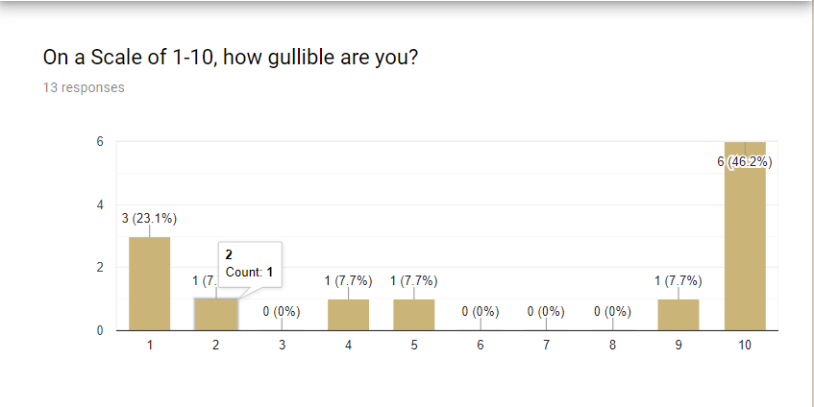

Our Market Research has demonstrated that people possess an overwhelmingly high degree of gullibility.

Thus, we can conclude we can offer insanely risky investments that may yield high returns, and people will buy, as we will “guarantee” success.

There are two outcomes.

We succeed in our endeavor, and our image skyrockets, and our customer base will increase.

We trade in inside information, succeed in our endeavor, and customer base will increase.

However, some people are somewhat less gullible, so we offer high-load mutual funds that match the S&P 500.

Form Research: [hformsresearch](https://docs.google.com/forms/d/1VOeHwZv2kOFiLCPT1vDzjv_ttRwIkPUudueQV_MWJAo/edit?usp=sharing)

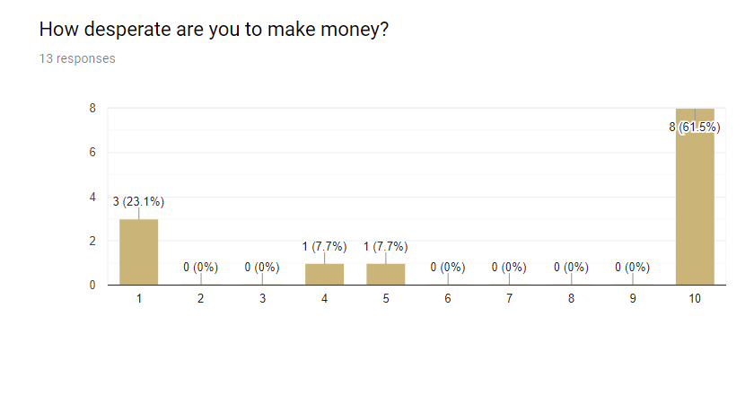

Again, this demonstrates the younger generation is willing to invest in high-risk cryptocurrencies. Illicit activities show some promise.

**S.W.O.T. An****alysis**

Strengths:

We control several cryptocurrencies, and employ only the finest employees. Furthermore, we are one the few catch-all financial services – we steal your money at every step of the way.

Weaknesses:

Our profit margin is very low, and our image is shady for some reason.

Opportunities

People are extremely gullible. Thus, they spend on items they will never use. We aim to

eliminate excess through our financial advisory firm.

Since our business is convenient, we know customers will return, and we will steal their money

Each step of the way. We eliminate the middleman, optimizing profits.

People are willing to invest in shady businesses and small-cap funds.

Threats:

TotallyLegitBusiness threatens our business; currently, it’s dominating the market. However, our

tax lawyer has found traces of corporate espionage.

**Emplo****yees**

Marketing Manager: $50,000/year. His job is to reach out to our customer base.

Accountant: $45000/year.

Interns: Paperwork Galore. $1000/year

Tax Lawyer: 5000/year. Works part-time.

Mutual Fund Manager: Largely automated. Matches S&P 500. Cost: $250 yearly.

Chief Executive: $100000/year.

Broker: $45000/year. Manages transactions.